Sleepez

Web322 Assignment 1/2

Christopher Kelly

Ckelly28@myseneca.ca

Kadeem Best



**Table of contents:**

Introduction…………………………………………………………………………………………………………2

Tools Used………………………………………………………………………………………………………….2

Description of Pages……………………………………………………………………………………………2

Screenshots………………………………………………………………………………………………………..3

**Introduction:**

For this first assignment, we are tasked to create a website similar to Air B&B. The functionality required in this first module is limited to setting up a server, route handling, and creating multiple views from templates.

I have named my website SleepEZ and included a custom logo as well as a video tutorial on the website itself.

**Tools Used:**

For the first part of this assignment, I used Node.JS with the following packages installed:

-Express

-Express-Handlebars

-Body-Parser

Express allowed me to setup the server. Handlebars allowed me to create templates, and Body-Parser was used to parse information from forms in order to validate information and display the correct results.

**Description:**

*Home:* The homepage is where most of the magic happens. The search function is fully functional and requires valid data. The city gets stored into the app.js file and redirects the user to the Room List page. Only the city stored in “City” gets shown here.

There is a section as well for information about the website that includes testimonies and a video tutorial about how to use the website. The video is a screen capture showing the functionality of the website

*Room List:* This is a page that only displays rooms from city chosen by the user in the search section of the home page. Each city has unique rooms and prices.

*Registration:* The Registration Page includes basic registration questions with some functionality. Currently the only error handling is for missing names and dates of birth. Upon successful registration, the user is directed back to the home page and their name is displayed in the top left corner.

**Screen Shots:**

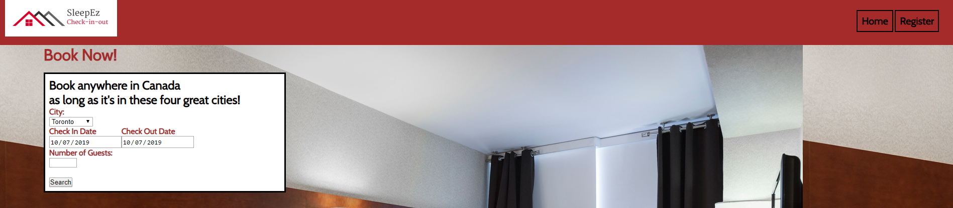

**Default Nav Bar with search Section**

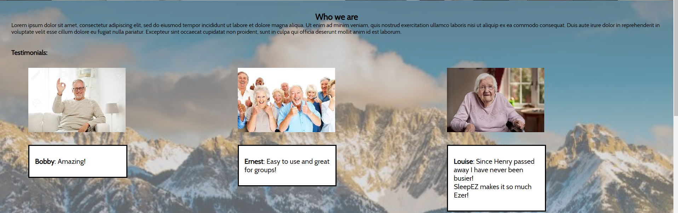

**Testimonial Page**

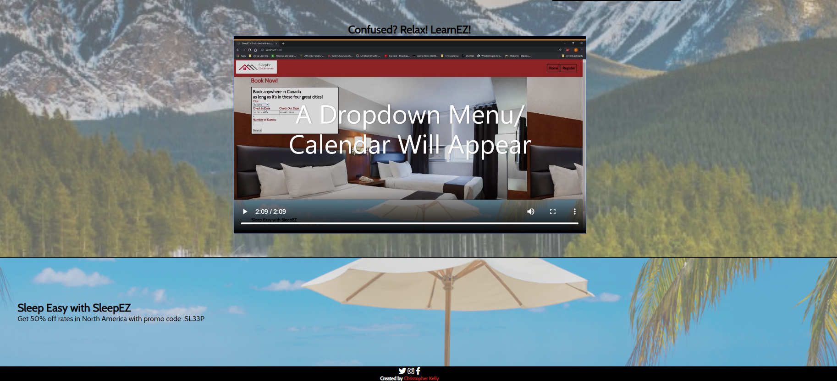

**Tutorial Video with promotion and footer at the bottom of the page**

**Registration:**

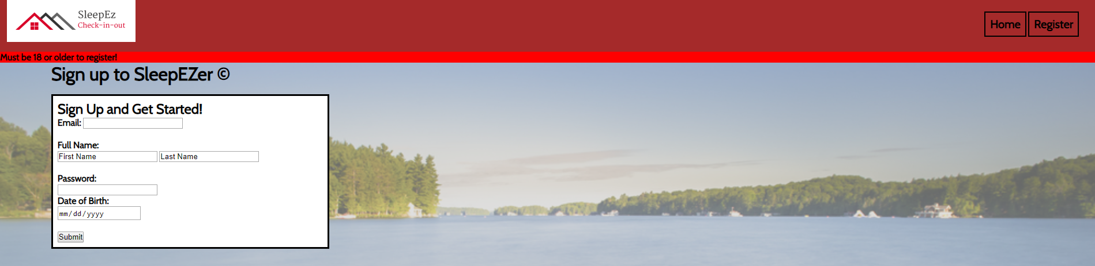

Registration form with birthday entered using yesterday’s date.

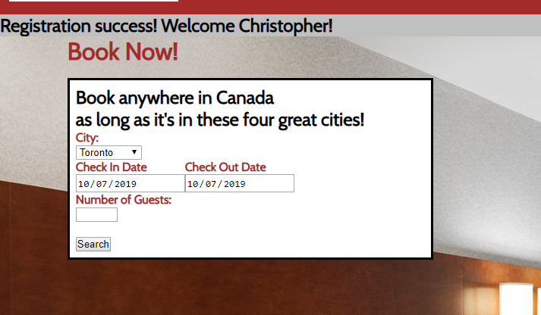

Registration successful!

**Room Listing:**

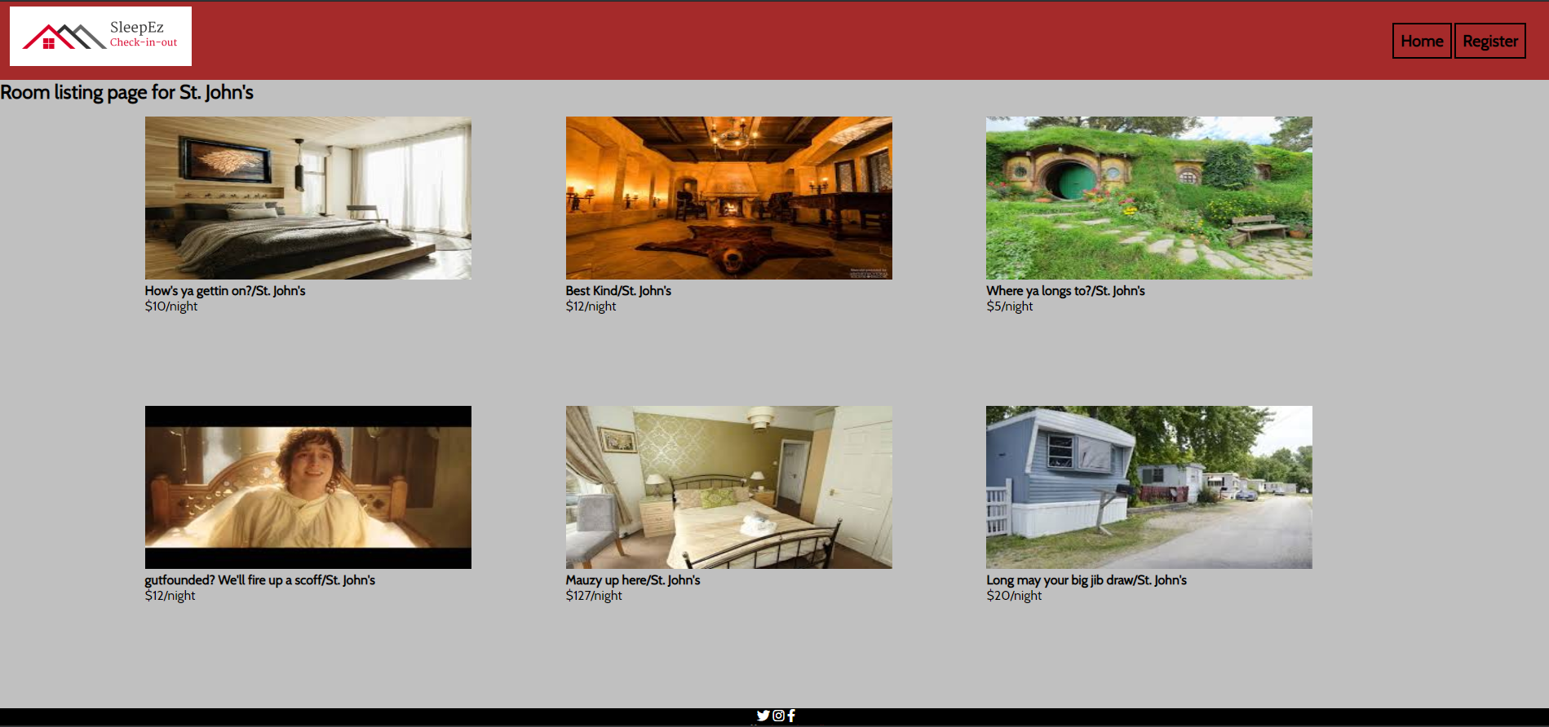

**Room listing view for St John’s showing images and prices. Footer can be seen below**

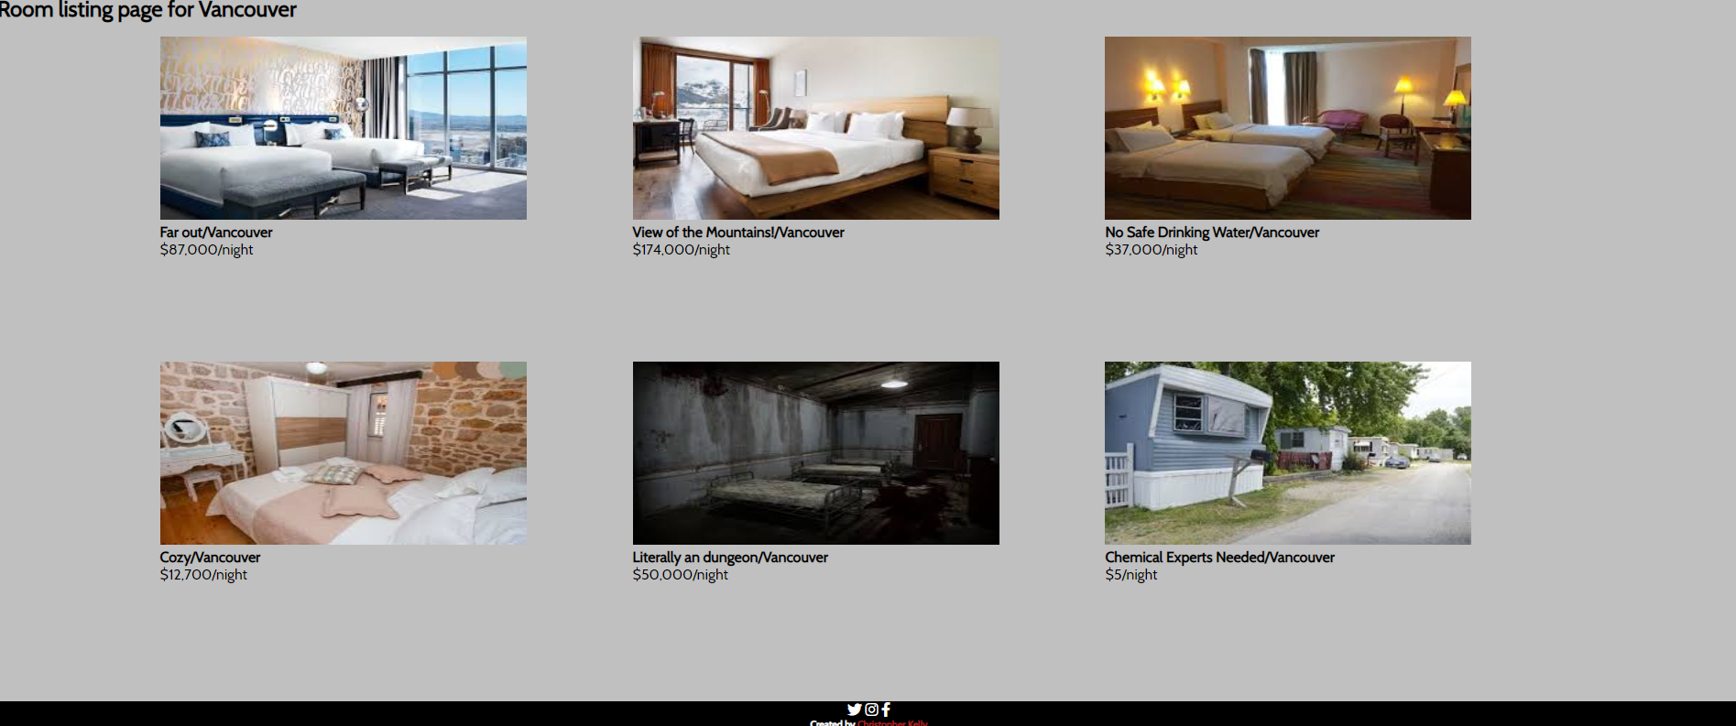

**Vancouver listing shown here as well**